Computer Language Coding Concepts

Related Lists
A related list is a system object. A related list is contained by a parent object. It is the result of a →n relation. The system interface of a related list manages the relation between a parent and the related list it contains. How a system object manages a relation between a parent and its sub-objects has been explained in the article Related Item.

A related list contains multiple related list items, which are also system objects.

A related list with its system interface and some related items in it are displayed in a diagram as follows:

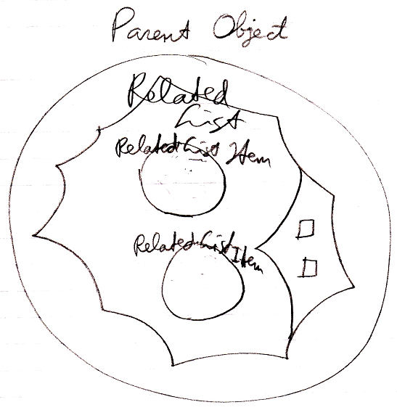

A related list has the following members:

Add
Name
ID In Parent

These members will be covered by the articles:

- Add
- Names of Related Items & Related Lists
- Related Items & Related Lists Collections

Each item in the list has different data in its system object, but extensions to the procedures around assignment or retrieval of an item in the list are the same for each item. That’s why the extension procedures of related list items are defined inside the related list.
A related list’s system interface has objects, that define the extension procedures of related list items’ system commands:

Item New
Item Annul
Item Created . Get
Item Created . Set
Item Object . Get
Item Object . Set
Item Other Related Item . Get
Item Other Related Item . Set
Item Other Related List Item . Get
Item Other Related List Item . Set
Item Value . Get
Item Value . Set
Item Remove

The complete system interface of the related list system object looks like this:

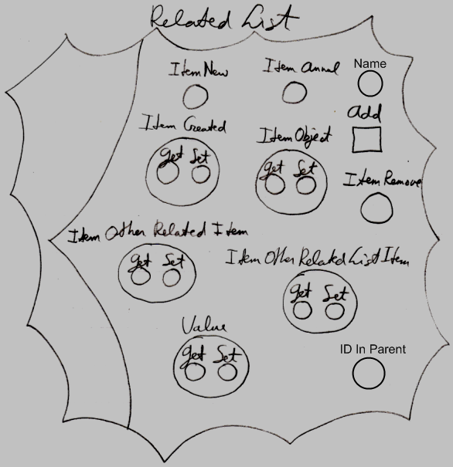

So most of those are objects, not commands. The objects only contain references to the extension procedures for related list items.

The related list item members that get extended are covered in the articles:

- New & Annul
- Object Get & Set
- Pointer To Pointer Get & Set
- Value Get & Set
- Remove

For further information about extending the system commands, see the article Extending the System Interface.

See also: System Objects, Add, Names of Related Items & Related Lists, Related Items & Related Lists Collections, New & Annul, Object Get & Set, Pointer To Pointer Get & Set, Value Get & Set, Remove, Extending the System Interface

Author & Copyright: Jan-Joost van Zon Date: July 14, 2008 – July 24, 2009 Location: Oosterhout, The Netherlands Status: Finished

Ideas
Related Lists,
2008-08-10

You can’t always display all items in the list, if there are too many. You have to have a way to scroll through them. And parhaps you should be able to open up a table view.

JJ

